# Exercise: HTML and CSS: Box Model, Containers and Flexbox

## Box Model Container

Create a web page like the following:

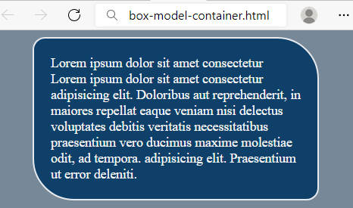

### Requirements

You will be given a skeleton with **filled** **HTML** and an **empty** **CSS** file. Write the missing **CSS** following the guidelines in the task.

* <body>
  + Background color: **lightslategray**
* <p>
  + Width: 300px
  + Paddings: 20px
  + **Auto** margins
  + Background color: **#0F4069**
  + Text color: **whitesmoke**
  + Solid border with size 2px and color #e6eaef
  + Top left and bottom right border radius: **15px**
  + Top right and bottom left border radius: **50px**

## Brazil Coffee

Create a web page like the following:

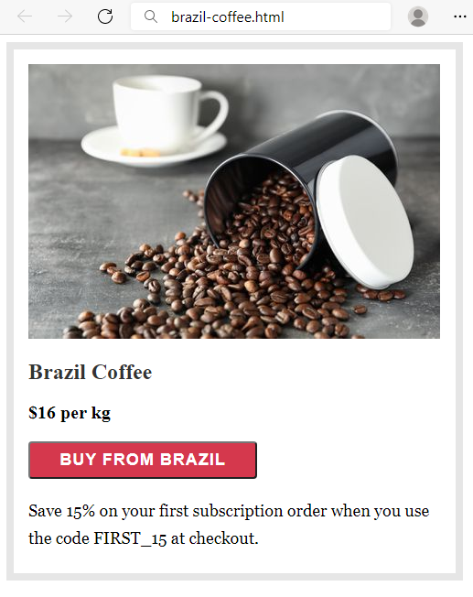

### Requirements

HTML with <body> that contains: <section> which has <img>, <h2>, <div>, <button> and <p>.

CSS:

* <section>
  + Solid border with size 8px and color #e6e6e6
  + Paddings: **16px**
  + Width: **451px**
  + Height: **540px**
* <h2>
  + Font: **Merriweather**
  + Generic Font: **serif**
  + Font weight **700**
  + **Top** & bottom margin 1.2rem
  + **Left** & **right** margin 0
  + Color: rgb(51, 51, 51)
* <div>
  + Font weight **600**
  + Font size: **20px**
* <button>
  + Width: **250px**
  + Font: **Work Sans**
  + Generic Font: **sans-serif**
  + Font weight **600**
  + Font size: **18px**
  + Border radius: **4px**
  + Background color: #**d5384d**
  + Text color: **#fff**
  + Letter spacing: **1px**
  + Align the **text** to the **center**
  + **Top** & bottom padding 8px
  + **Left** & **right** padding 16px
  + Top margin: **20px**
  + Bottom margin: **20px**
* <p>
  + Fonts: **Georgia**, **Cambria**, **Times** **New** **Roman**, **Times**
  + Generic Font: **serif**
  + Font size: **18px**
  + Height of the line: 30px
  + Top margin: **0**

## Article

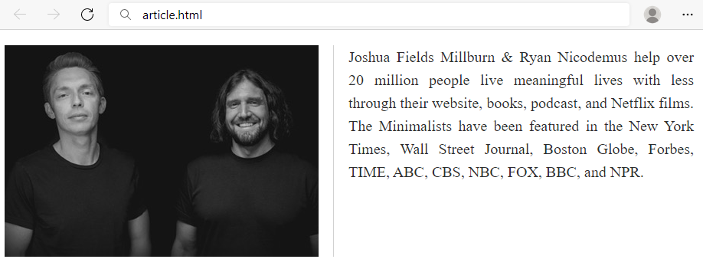

### Requirements

You will be given a skeleton with **filled** **HTML** and an **empty** **CSS** file. Write the missing **CSS** following the guidelines in the task.

* <main>
  + Width: **900px**
  + Height: **140px**
* <img>
  + Solid **right** border with size 1px and color **#d1d1d1**
  + Float the images on the **left**
  + Right margin: **19px**
  + Right padding: **19px**
* <p>
  + Font size: **20px**
  + Height of the line: 30px
  + Text color: #2e2e2e
  + Text align: justify

## Navigation Inline Block

Create a web page like the following:

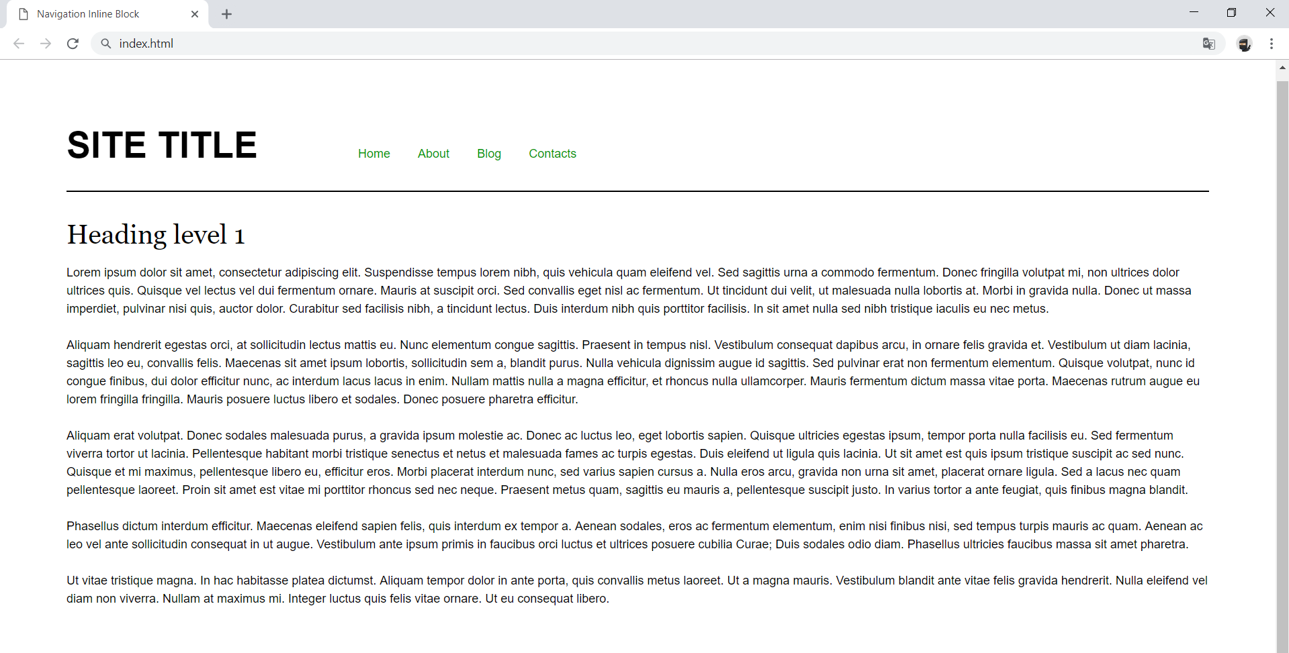

### Requirements

* Change the document title to "**Navigation Inline Block**"
* Divide your content into header and main tags
* Add font to the document: **Helvetica**, **sans-serif**
* Create a navigation bar
  + Add four list items in nav tag with a tags inside
  + Add display: inline-block; style for each item in the nav

## Photo Gallery Inline Block

Create a web page like the following:

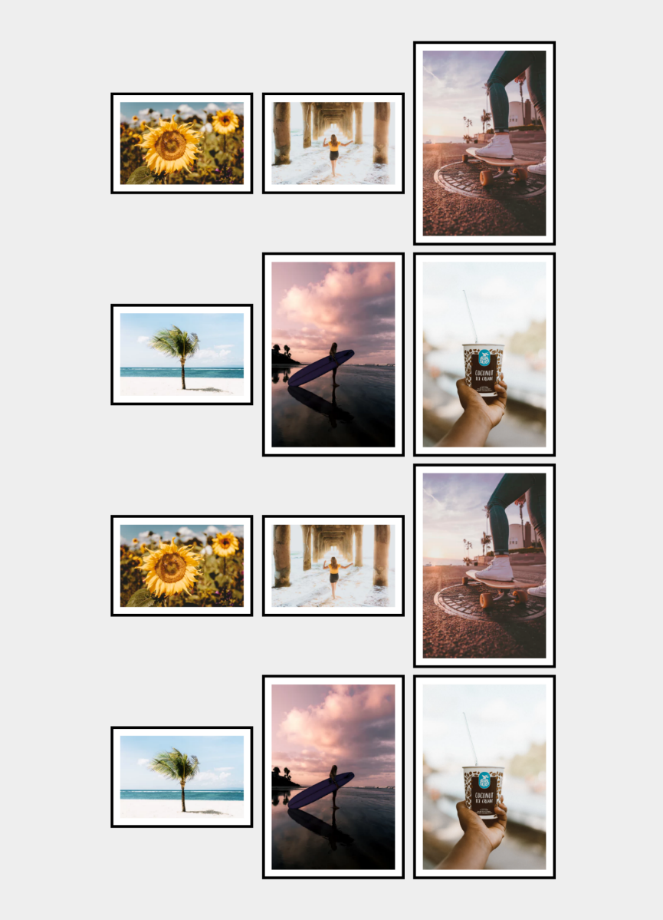

### Requirements

* Change the document title to "**Photo Gallery - Inline Block**"
* Create unordered list with **class** gallery (ul.gallery)
* Add list items with images inside
* **<body>**
  + Padding: **5rem**
  + Background color: **#eee**
* **.gallery**
  + Width: **100%**
  + Margin**: 0 auto**
  + Align the text to the **center**
* **li**
  + Width: **18rem**
  + Display the list as **inline-block**
  + Background color: **#fff**
  + Solid border with size 0.4rem and color **#000**
  + Padding: **1rem**
  + Vertical align: **middle**
  + Margin: **0.5rem**
* **img**
  + display: **block**
  + width: **100%**
  + height: **auto**

## Position Playground

Create a web page like the following:

Картина, която съдържа екранна снимка, изкуство

Описанието е генерирано автоматично

* Change the document title to "**Positioning Playground**"
* Import [Font Awesome](https://fontawesome.com/) into your **CSS** file

### Requirements

* Add two container units **(**divs**)** with class viewport inside the body
  + Inside each one adds section with class card *(*section.card*)*
    - Change the display property to block
    - Try to center the section with position property absolute

## Center Position and Transform

Create a web page like the following:

Картина, която съдържа текст, екранна снимка, лого, Марка

Описанието е генерирано автоматично

* Change the document title to "**Center Position and Transform**"

### Requirements

* **Section** tag must have **class="card"**
* Create section with two divs
  + First div contains image
  + Second div contains**: <h3>**, **<p>** and **a** tags
* Use rgb(238, 238, 238) for body background
* Use rgb(255, 255, 255) for card background
* Use rgb(0, 153, 0) for card button background
* Use font Georgia, serif with size 1em/1.2 for the headings
* Set the image position property to absolute

## Navigation

Create a web page like the following:

Картина, която съдържа текст, екранна снимка, документ, дизайн

Описанието е генерирано автоматично

* Change the document title to "**Navigation**"

### Requirements

* Create a header with a p for as title
  + Inside the header add a nav with a ul and 4 li elements
* Create a main, which contains an article with a header and h1 heading
  + Add a section inside the article
* Create an aside element with two sections inside
  + The sections should have a h3 heading and a navigation - nav with ul, li and a elements
* Use rgb(0, 102, 0) for the anchors
* Use rgb(238, 238, 238) for body background
* Use rgb(255, 255, 255) for image background and rgba(0, 0, 0, 0.25) for image box shadow
* Use font Georgia, serif for the blockquote
* Use font Georgia, serif with size 1em/1.2 for the headings

## Social Media Icons

Create a web page like the following:

Картина, която съдържа бял, черен, дизайн

Описанието е генерирано автоматично

* Change the document title to "**Social Media Icons**"
* Use FontAwesome to add social icons

### Requirements

* All you need for your HTML are ul, li and a tags
* Change the ul display property to inline-block
* Remove list items default style
* Each a tag must have border-radius: 50%;
* Check the provided screenshots to see the hover effects

## Flexbox Layout

Create a web page like the following:

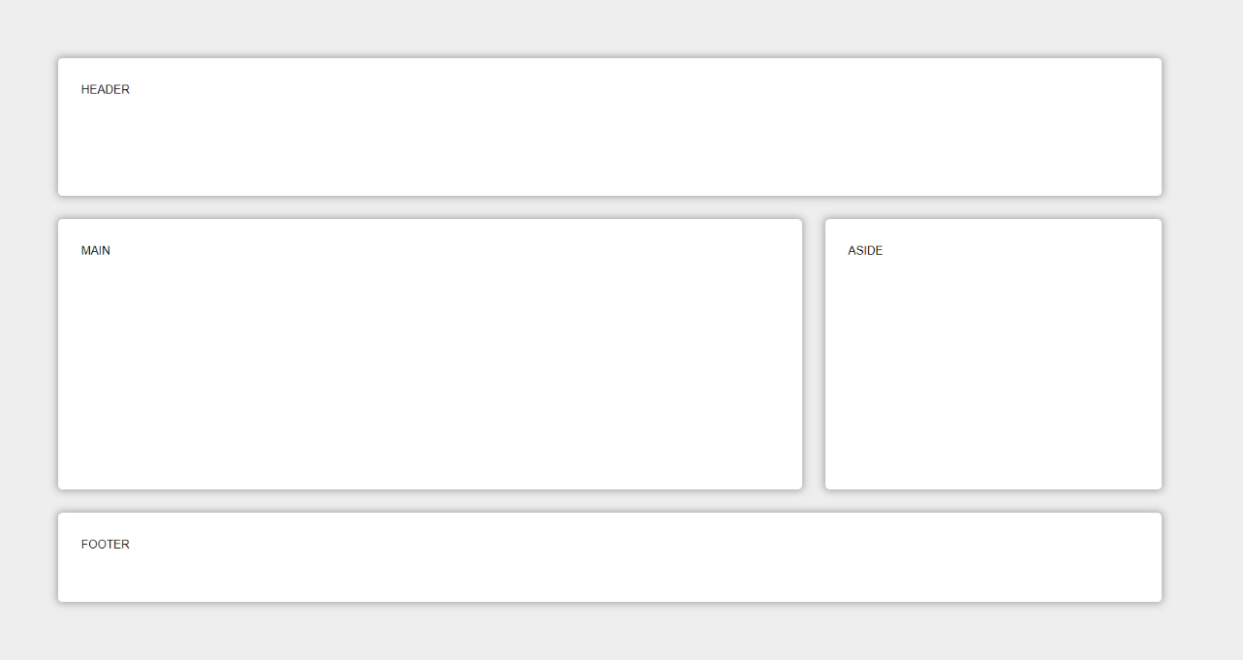

* Change the document **title** to "**Flexbox Layout"**

### Requirements

* Create header, main, aside and footer elements
* <body>
  + background color - **#EEE**;
  + padding - **5rem**;
  + display - **flex**;
  + flex-wrap - **wrap**;
* Each element (**<header>, <main>, <aside>, <footer>**) must have
  + padding - **2rem**;
  + background color - **#FFF**;
  + border-radius - **0.4rem**;
  + color - **#000**;
* **<header>** and **<footer>**
  + flex-basics - **100%;**
* **<main>**
  + flex - **8 1 40rem**;
* **<aside>**
  + flex - **2 1 20rem**;

## FlexModel Articles

Create a web page like the following:

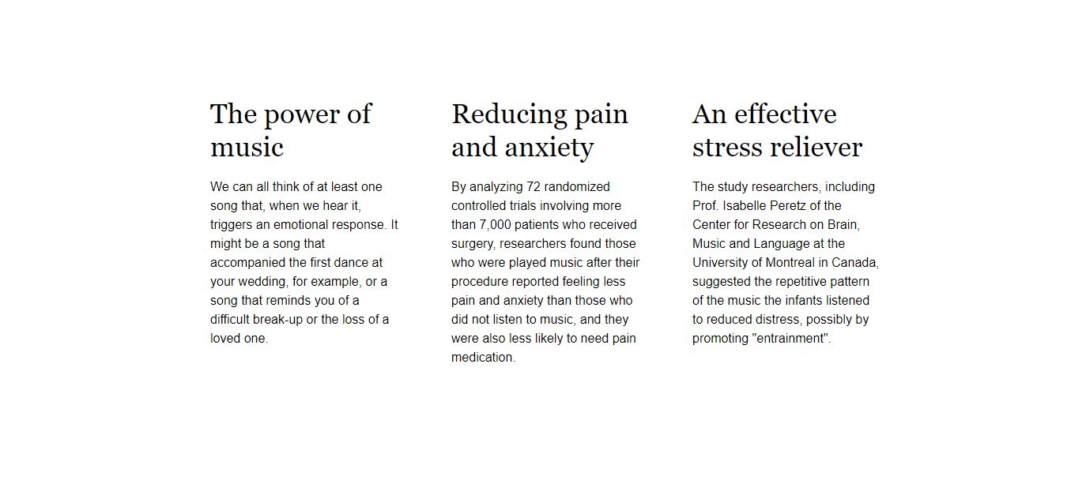

* Change the document **title** to "**Articles"**

### Requirements

* Create a section with three articles inside
* The article should have a h2 title and a paragraph (p)
* Fonts
  + Font family Helvetica, sans-serif with line height 1.5 for the html
  + Font family Georgia, serif with line height 1.2 for the headings
* Change the section display property to flex and set justify-content: space-between
* Set on the section max-width 70vw

## ABC Game

Create a web page like the following:

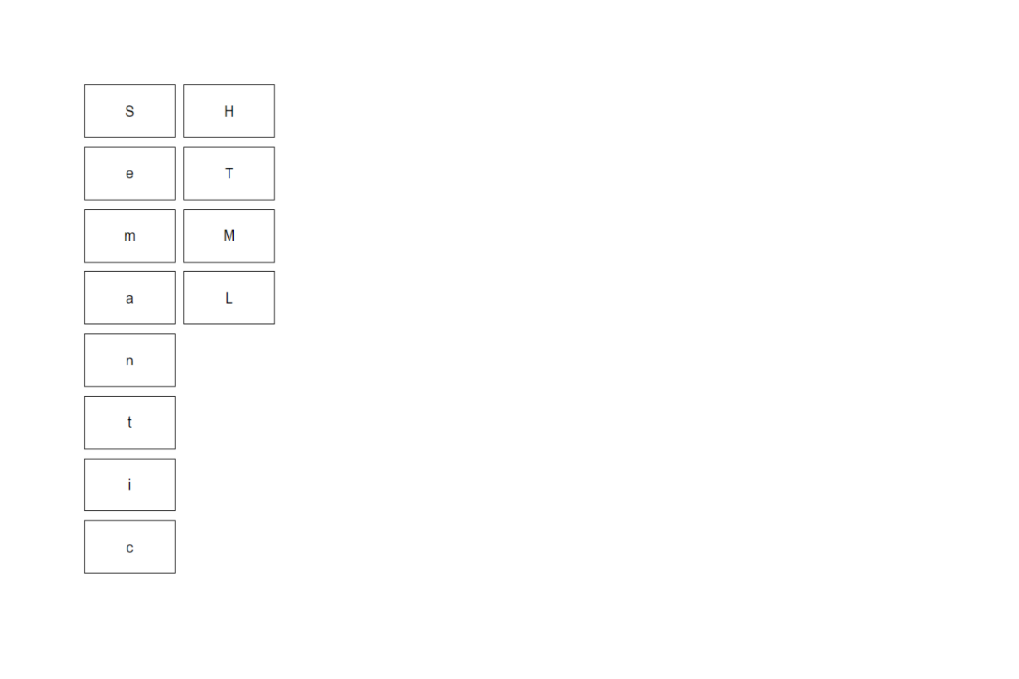

* Change the document **title** to "**ABC Game"**

### Requirements

* Create a div with class container and twelve span tags inside
* Type the letters in the spans EXACTLY as they are in the file text.txt
* Use font-family: Helvetica, sans-serif, with font-size: 20px
* Change the div display property to flex and align the items in center
* Set on the div max-width: 15vw and height 35rem
* The span must have
  + Border width - 1px
  + Border color - black
  + Border style - solid
* To arrange the letters, use the **flex property order**

## Calendar

Create a web page like the following:

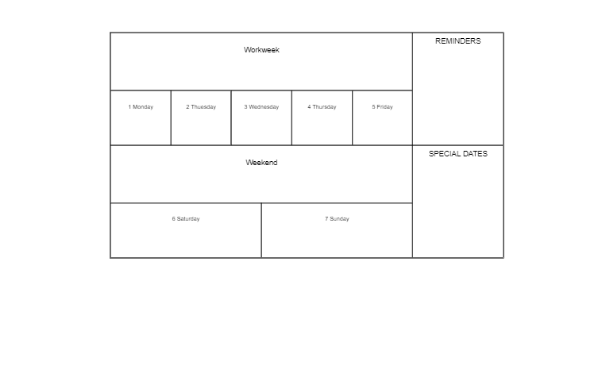

* Change the document title to "**Calendar**"

### Requirements

* Create a div with class **container** and two sections inside
  + First section has class week
  + Second section has class notes
* Use span tags for all content
* Change the div and sections display property to flex and align the items in **center**
* Set on the div max-width 65vw
* The span must have
  + Border width - 1px
  + Border color - black
  + Border style - solid
* For the section with class notes use the property flex-direction column
* Set on all HTML elements the property box-sizing: border-box

## Navigation Flexbox

Create a web page like the following:

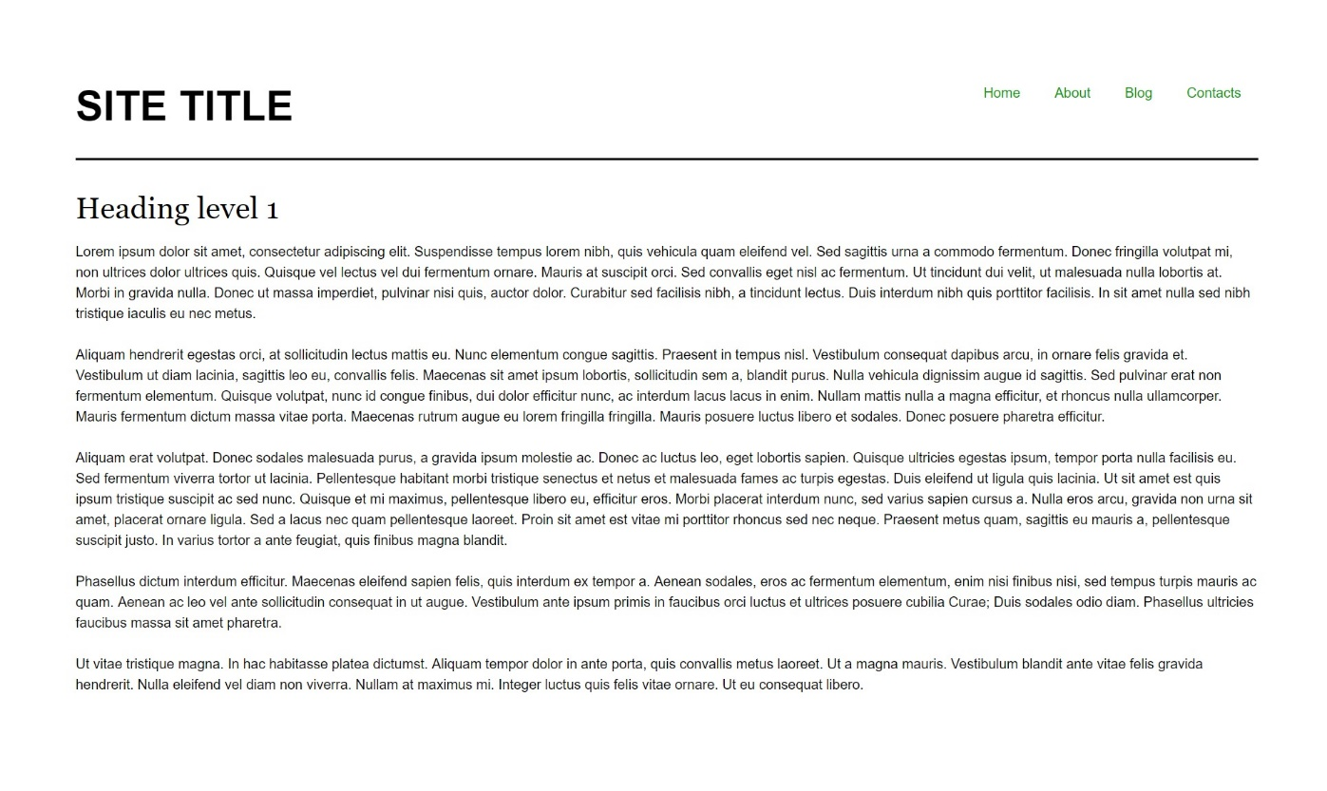

* Change the document title to "**Navigation - Flexbox**"

### Requirements

* Divide the **body** into header and main tag
* The **bottom** **border** in the header must have
  + Border width - 2px
  + Border color - rgb(0, 0, 0)
  + Border style - solid
* The **display** property of the header must be flex
* The **unordered** list in the header must have display property flex
* The **anchors** text color in the navigation must be rgb(0, 153, 0)

## Photo Gallery – Flexbox

Create a web page like the following:

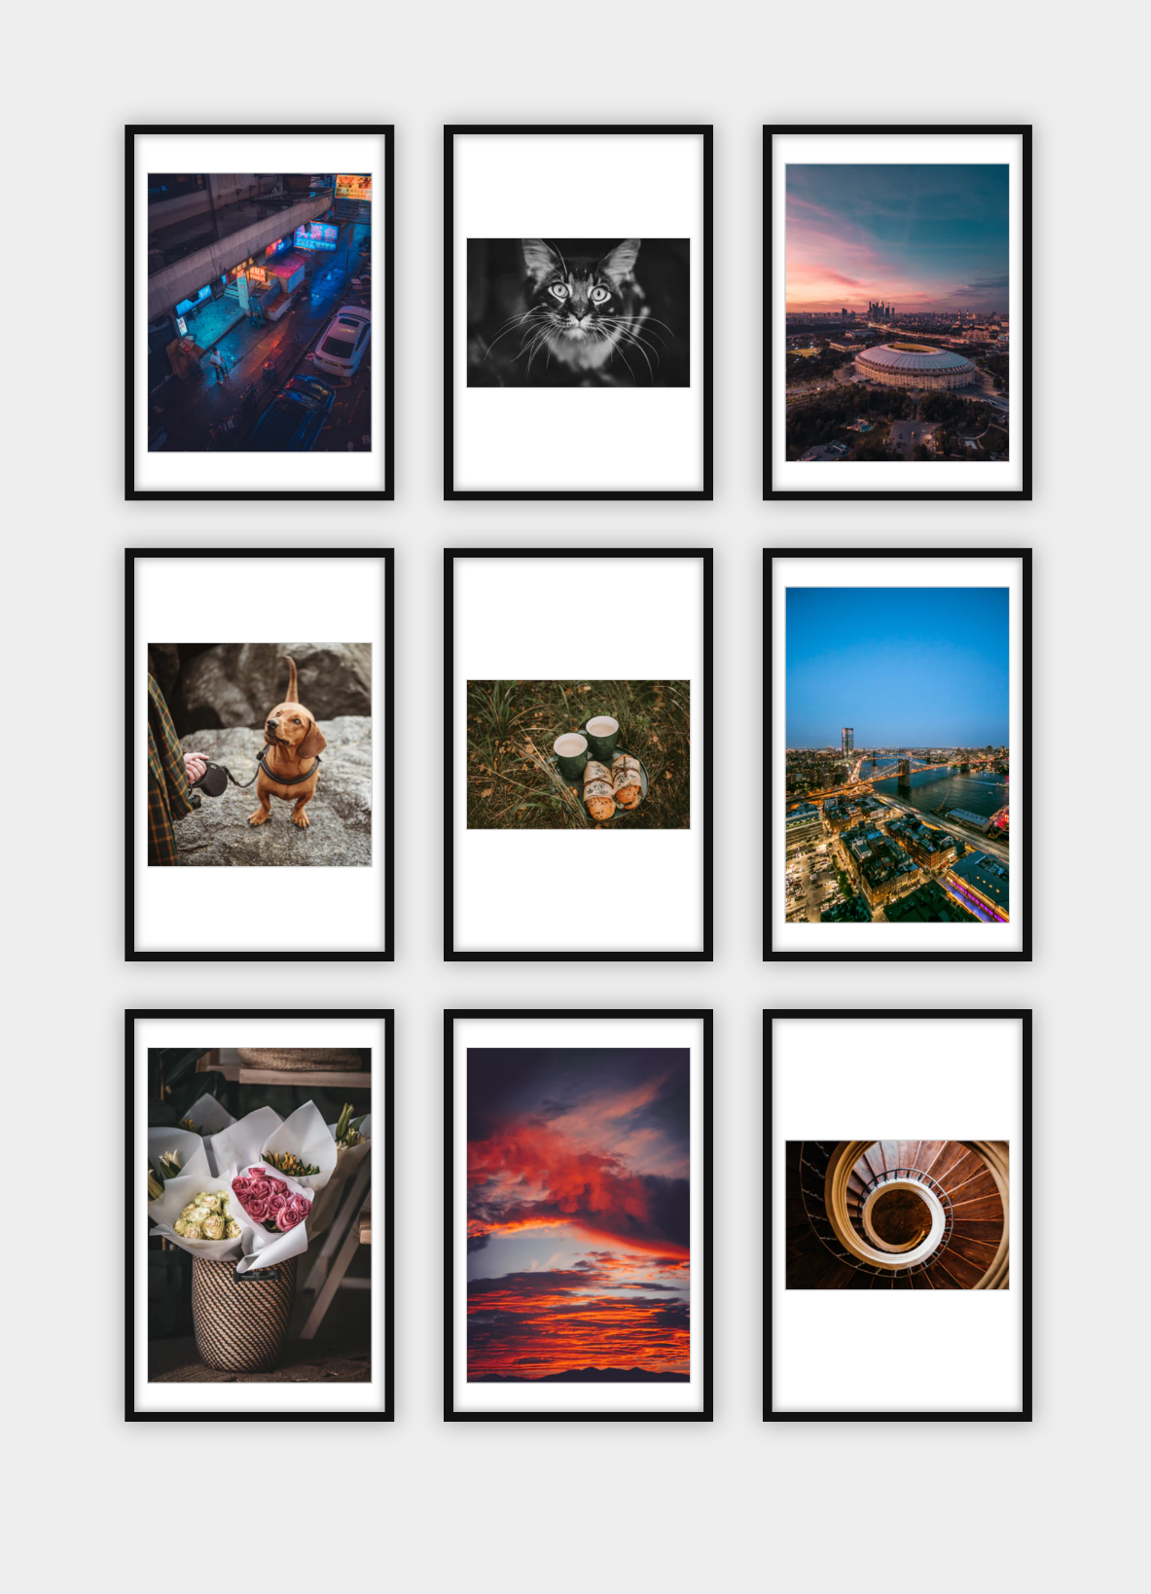

* Change the document title to "**Photo Gallery - Flexbox**"

### Requirements

* Add section with class gallery (section.gallery)
* Add **unordered lis**t with **list** items and **images** inside
* Change the body, ul and li display property to flex
* Set the **ul** property **justify-content** to be equal to **space-between**

## Blog Layout – Flexbox

Create a web page like the following:

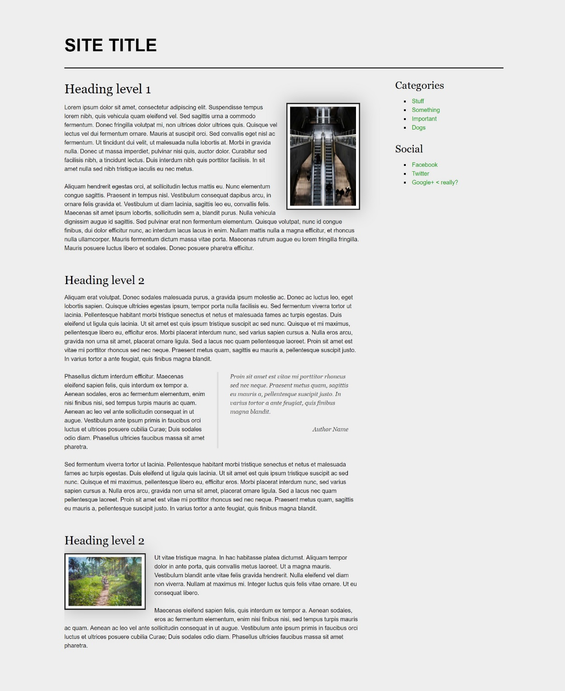

* Change the document title to "**Blog Layout - Flexbox**"

### Requirements

* The entire content must be in div container with **class** page (div.page)
* The page container (div) must be **flexed** and **wrapped**
* **Body** **background** color must be rgb(238, 238, 238)
* **Image** **background** color should be rgb(255, 255, 255)
* **Blockquote** font family must be Georgia, serif
* The **anchors** text **color** in the aside section must be rgb(0, 153, 0)
* Page **headings** font family must be Georgia, serif

## Sticky Footer – Flexbox

Create a web page like the following:

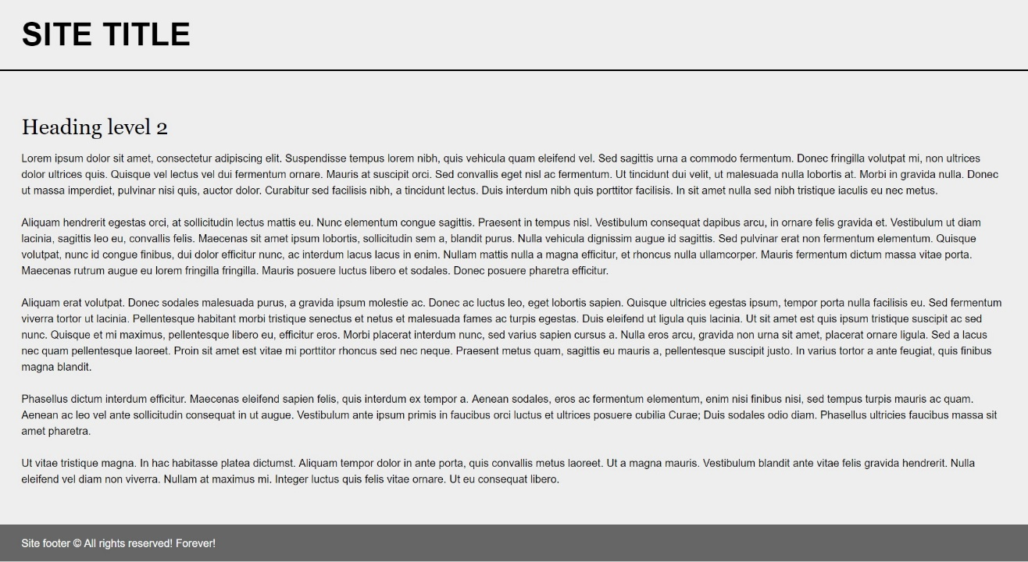

* Change the document title to "**Sticky Footer - Flexbox**"

### Requirements

* Divide your content into header, main and footer tags
* The **body** must have flex display property
* The **body** **background** must be rgb(238, 238, 238)
* Set **height** to the body: 100vh
* Font family Helvetica, sans-serif
* The footer should be at the bottom of the page
  + The footer text color must be rgb(255, 255, 255)
  + The footer background color must be rgb(102, 102, 102)

## Center Flexbox

Create a web page like the following:

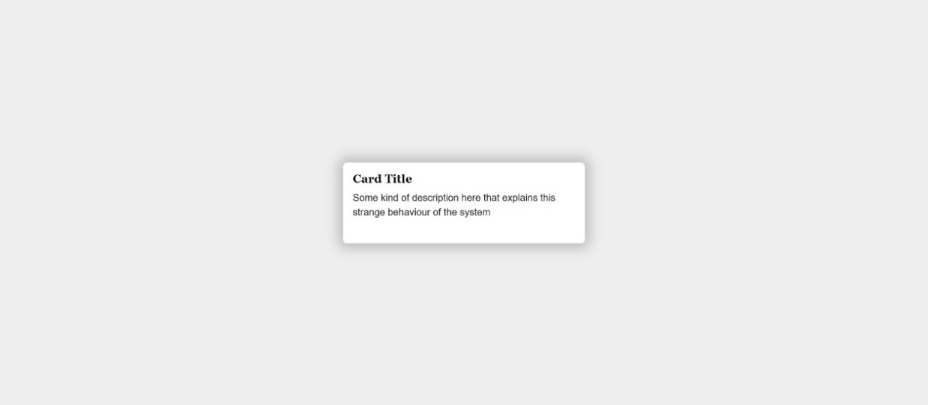

* Change the document title to "**Center Flexbox**"

### Requirements

* The **body** **background** color must be rgb(238, 238, 238)
* The body **display** property must be flex
* The content must be placed into **div** with **class** card (div.card)
  + The div background color must be rgb(255, 255, 255)